|  |  |
| --- | --- |
| Team ID | PNT2022TMID48924 |
| Project Name | Personal Assistance for Seniors Who Are Self-Reliant. |
| Date | 19 November 2022 |

Objective:

Create a function to compare time.

1. Function node:
   * After log in to the Node-RED
   * In the Node panel you will find function block
   * Write the code form compare the time

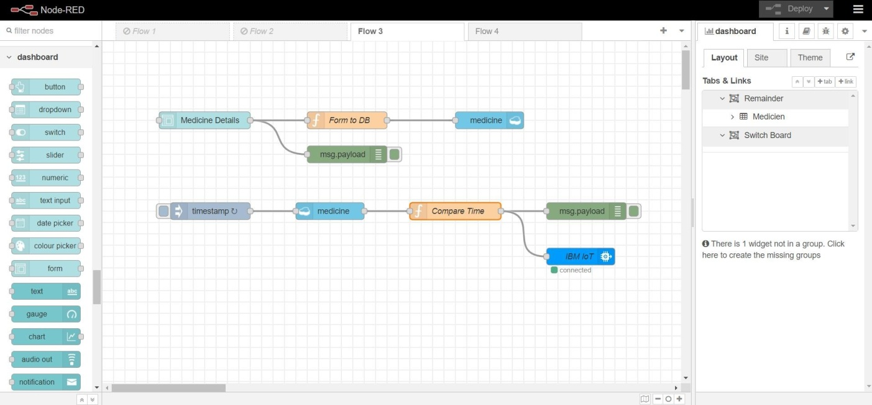

1. Code for Compare time:

var date1 = new Date();

var hour=date1.getUTCHours(); var min=date1.getUTCMinutes(); var sec=date1.getUTCSeconds(); hour=hour+5

min=min+30 if(min>60){

hour=hour+1 min=min-60

}

var c=msg.payload; var m = [];

for (let i = 0 ; i<msg.payload.length; i++){ if(hour===c[i].payload.Hour){

if(min===c[i].payload.Min){ if(sec===0){

m.push(c[i].payload.Tablet);

}

}

}

}

msg.payload={"command":m}; return msg